# after an assault

Find a safe place and seek assistance by calling 911 or local rape crisis center. If you are going to report and have a medical forensic medical exam the following are not action recommend doing until exam is completed.

* Do not change your clothes.
* Do not urinate, bathe/shower, eat, or drink, comb your hair or douche.
* Do not touch, move, destroy, or discard anything from the scene of the crime.

The police and/or local rape crisis center will assist you in seeking medical attention to determine any injuries you may not feel. By obtaining medical attention you can receive follow-up care for determining pregnancy and possible STD’s.

Sex assault victims will not incur out of pocket expenses for forensic medical exam.

Common Reactions During a Sexual Assault

**Freezing:** Being unable to think, move or speak when your life is being threatened is common.

**Yielding:** You may have pretended to cooperate or gave in. Many survivors were able to figure out what the perpetrator wanted by giving in or pretending to minimize injuries or death.

**Bargaining:** Some survivors will try to cut a deal during the assault. For example, it may have been performing one sex act if the perpetrator agrees not to do another or convincing perpetrator to wear a condom or having sex in exchange for protection.

**Physical Fighting:** There are many ways to fight. Anything you did to survive was fighting back. Some survivors screamed, kicked, hit, scratched, and pushed back, the rapist who is not looking for a fight may give up. Many rapists are/were looking for a fight and respond more violently. Any of responses listed are ways that survivors fought back.

**Terror and Disbelief:** Many survivors experience feeling of extreme fear, helplessness, and hopelessness during an assault. A sexual assault is an experience where you do not have control over what is happening to you. Terror, which does not go away when the assault is over, is a normal reaction.

**Sexual Response:** It is normal to experience some sexual response during an assault that would otherwise signal sexual pleasure for the body. A sexual response can make survivors feel very ashamed, but this does not mean you wanted or liked what was happening to you. The body is designed to respond to touch. You have nothing to be ashamed of.

**IN EMERGENCIES**

**CALL 911**

Lone Peak Police Department 801-756-9800

**Alcohol and Drug Abuse**

Alcoholic Anonymous 801-375-8620

Narcotics Anonymous 801-373-7060

**Campus Resources**

BYU Women’s Center 801-422.4877

UVU Women’s Center 801-863.8080

**Counseling**

Wasatch Mental Health 801- 373-4760

Affiliated Family Treatment 801- 377-1595

Intermountain Specialized Abuse Treatment (ISAT) 801- 886-8900

Addiction & Psychological Services 801-222-0603

Family Support & Treatment 801-.229-1181

LDS Family Service (non-profit) 801- 216-8000

**Crisis Hot Lines**

Rape Crisis Center 801-356-2511

Suicide Hope Line 800-273-8255

Utah Coalition Against Sexual Assault

801-746-0404

**Financial Services**

Crime Victims Reparations 800-621-7444

Department of Workforce Services 801-492-4500

Tabitha’s Way Food Pantry 801-692-1881

Food & Shelter Coalition 801--373-1825

Community Action 801-373-8200

**Housing**

Utah County 801-373-8333

**Legal Services**

Utah Legal Services 800-662-4245

Lawyer Referral Service 800-698-9077

Family Justice Center 801-851-8508

**Medical Services -**American Fork Hospital 801.763-3555

Mountain Pointe Medical Center 385-345-3000

**Shelter**

The Refuge (UT County) 801-377-5500

Family Support & Treatment Center) 801-229-1181

YWCA (Salt Lake City) 801-537-8600

**VINELINK** (jail release notifications) 877-884-8463

Dial 211 for local services and referrals

**Sexual Violence**

Sexual Violence occurs anytime a person is forced, coerced and/or manipulated into any unwanted sexual contact; attempted or completed.

Sexual Violence can happen to anyone, anywhere, and anytime, regardless of age or gender. Sexual Assaults are not always committed by strangers. Often, sexual violence is committed by a parent, sibling, family member, babysitter, roommate, friend, date, spouse, boyfriend or girlfriend and it is most often someone you know and trust.

Sexual Violence is not a crime of lust. It is a crime of power and control. In all cases of sexual violence, no one is to blame, but the perpetrator, who must be held accountable for his or her actions. A common misconception is that sex offenders cannot control their sexual urges and are driven to commit these crimes.

No One Deserves to Be Sexually Assaulted

Things that Cause Rape

* Revealing/Inappropriate Clothing
* Alcohol
* Flirting
* Walking Alone
* TV/Movies
* Nighttime
* Minorities
* Weather
* A Promiscuous Past
* Rapist

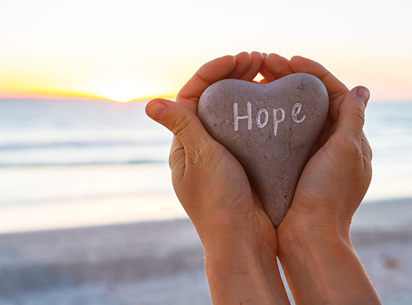

LONE PEAK POLICE

DEPARTMENT

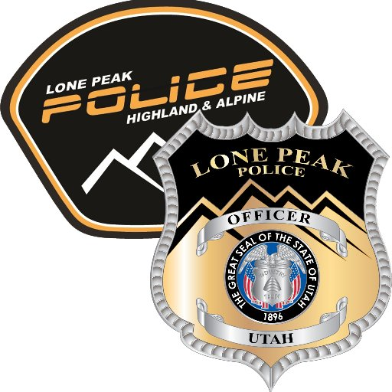

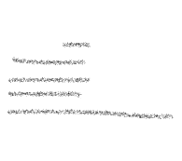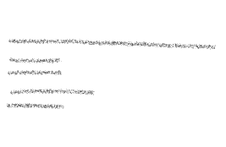+



Sexual Violence

Victim Assistance

Resource Guide

Case #:__________________________

Officer/Detective:

_____________________________

Cindy Bergman

801-772-4530

[cbergman@lonepeakpolice.com](mailto:cbergman@lonepeakpolice.com)

5400 W. Civic Center Dr. Ste 3

Highland, Utah 84003

**Safety Plan**

1**. Have a plan:** Tell family, friends, or roommates where you are going and when you’ll return. If possible, have or arrange for your own transportation. Be aware and know your surroundings.

2. **Know your own boundaries:** It’s your body you get to decide what your comfortable with and what happens with your body. No one should pressure you to go any further than you are comfortable with.

3**. Assess the situation:** Alcohol and drugs can interfere with others ability to respect an individual’s boundaries and can affect your own judgement. Whenever possible use the buddy system, especially at clubs and parties. Never leave your drink unattended.

4. **Trust your gut:** If you get a bad feeling about a situation, it’s probably for a good reason. Don’t worry about what other people think. Trust your feeling and try to get out of the situation as soon as you feel uncomfortable.

5. **No means no:** Take “no” to mean no and explain that you respect that decision and won’t pressure the person.

6. **Be careful around people you don’t know well:** Resist the temptation to put total trust in a new friend by accepting a ride or going to someone’s home. Just because one of your friends know someone doesn’t mean you should automatically trust them.

7. **Listen carefully:** Take time to hear what the person you are with is saying. If you feel you are getting mixed messages, ask for clarification. Be cautious of those who are overly charming with words and accelerate the relationship to quickly.

8. **Be aware of Isolation:** A partner may insist only spending time with you consistently. The person insists on you not spending time with family or friends or say you should wear your clothes or do your hair certain way. Uses jealousy and guilt to make you feel bad about spending time with family, friends, or your interest.

Tips for Parents, Family and Friends of Sexual Assault Victims

**Do not question the child/victim**. The child/victim my disclose additional information. It is very important to listen but not to question or judge child/victim. If child or victim over 18 discloses any new information, as a parent contact law enforcement and encourage victim to contact law enforcement.

**Do not blame child/victim.** Do not express emotions such as shame, blame or judgement, as these are reactions that could cause a negative lifelong impact for survivors. Remind your child/victim that you love them. A victim is never responsible for the actions of the offender.

**Do not correct child/victim anything they tell you about the incident**. You can respond by saying “ I am really glad you told me that” or “thank you for telling me.”

**Be careful about making promises.** Be careful not to promise rewards for cooperation. Be careful not to make promises about what will happen to offender. Be careful not to promise that nothing else bad will happen. In the days to come victims may experience flashbacks and feel powerless and fearful.

**Respect the victim’s privacy.** Be careful not to discuss what child/victim tells you with others if it is not necessary. Only discuss if the child/victim gives you permission to those who are not part of law enforcement.

**Keep your feeling under control when child/victim is present**. Expressing anger, shock, or judgment can make the victim feel ashamed. Showing anger towards the offender can scare a child/victim and the victim may feel they did something wrong. It may be upsetting for a victim to see you lose control. The victim needs those who are their support to maintain control because they were assaulted and had no control.

**A victim may have behavioral and emotional changes that affect relationships, daily activities, and moods.** A counselor can help with dealing with these emotions. The more consistency and choices, a victim has, will help them with feeling like they have control and are not powerless.

**Common Response for Sexual Assault Survivor’s**

It is important to remember there’s no one normal reaction or emotions to sexual violence.

* Post-traumatic Stress Disorder (PTSD)
* Shame
* Depression
* Self-Blame
* Denial
* Lack of trust with people or surroundings
* Alienation due to abuse
* Significate change in sleep patterns
* Drug or alcohol abuse
* Thought of death or suicide
* No desire for sexual intimacy or overactive sexuality
* Pretending like nothing happened
* Risky behavior
* Self-harm
* Disassociating or Spacing Out
* Flashbacks

**Taking care of yourself is the first step in the healing process after an assault. Consider follow up medical care and counseling. Keep in mind there are phases of healing for a Sexual Assault survivor.**

Sexual Assault is a personal and intimate violation of self.

**Stages of Rape Trauma Syndrome**

**RTS** describes the feelings, thought, reactions or symptoms that frequently occur after the assault. RTS has three phases that last different lengths and time for each person. You might experience them in order, or you might find you go back and forth.

**Crisis Phase:** The survivor’s life is disrupted and is left feeling overwhelmed, disoriented, and unable to cope. Survivors feel a wide range of emotions and have difficulty managing daily tasks. Nightmares, flashbacks, etc. occur making the survivor feel out of control.

No Means No

**Adjustment Phase:** Survivor’s feel a need to “get back to normal” and go with life. The intensity of emotions begin to fade. Depression is common.

**Integration Phase**: Many survivors’ report feeling like one person before the assault and another person after. Integration is when you accept the assault as part of your life experience and bring together aspects of those two halves of yourself in a way that works for you.

The healing process may take months or years. Please reach out to a trusted friend or professional or support group if you need help coping.

Help Stop Sexual Violence

**Examine your own attitudes:** Speak out against sexual assault. Sexual violence is not okay. Stand up and say so.

**Stop violent behavior:** Stop any person you see violating or exploiting verbally or physically. Declare sexist jokes and language unacceptable.

**Don’t join in:** Don’t join in if friends encourage you to participate in paying unwanted sexual attention to someone at a party, bar, or on the street. Sexual objectification can lead to sexual violence.

**Don’t make excuses:** Don’t make excuses for the crime by saying the victim shouldn’t have worn that, gone there, or drank that or was too flirtatious.

**Don’t treat sex as an obligation:** Never think your partner or acquaintance owes you sex under any circumstances. Sexual Intercourse is not a payback for an expensive meal, gift or an evening out on the town.

**No One Wants to be Raped:** Never believe or support the idea that a person “wanted it.” Sexual Violence is a violent crime, no one wants it to happen to them.

**Don’t perpetuate stereotypes:** Rape is a crime of power, control, and violence. It’s not about how a person looks. Don’t buy into the myth that rape is a crime of lust. A picture containing flower, plant, colorful
